Your StoreHub Training Journey: Foundation (Day 1-2)

Welcome to StoreHub Training!
You're about to embark on an exciting learning journey that will equip you with everything you need to succeed in your role. This overview covers your first two days of training- the foundation that every StoreHub team member builds upon.

🎉 Starting Strong: Highs, Lows & Buffalos Icebreaker

Before diving into content, you'll kick off training with a fun icebreaker activity led by Andrea:
- A High: Share a success or positive experience (personal or professional)
- A Low: Share a challenge you encountered
- A Buffalo (twist): Share a random or unexpected event

🎯 How This Training Works: The Self-Study Philosophy


You’re in Control.
This is a self-paced journey, and you're in the driver's seat. Your proactivity and accountability will shape your success. There's no trainer watching over your shoulder- you own your learning pace and outcomes.


We’ve Got Your Back.
While you're learning independently, you're not alone:

- Daily check-ins with your trainer keep you on track (and away from that Netflix rabbit hole!)
- Questions sheet provided for you to jot down any burning questions
- Trainer review sessions built into the schedule to address your concerns


Time Matters!
Every task has a set time limit, so managing your schedule is key. Check the training agenda to stay on top of things. If you fall behind, tasks can pile up- fast.


Some Parts Might Get Tricky.
Stay engaged, take notes, and don't hesitate to ask questions. Your trainer will go through them during check-ins- no question is too big or too small.

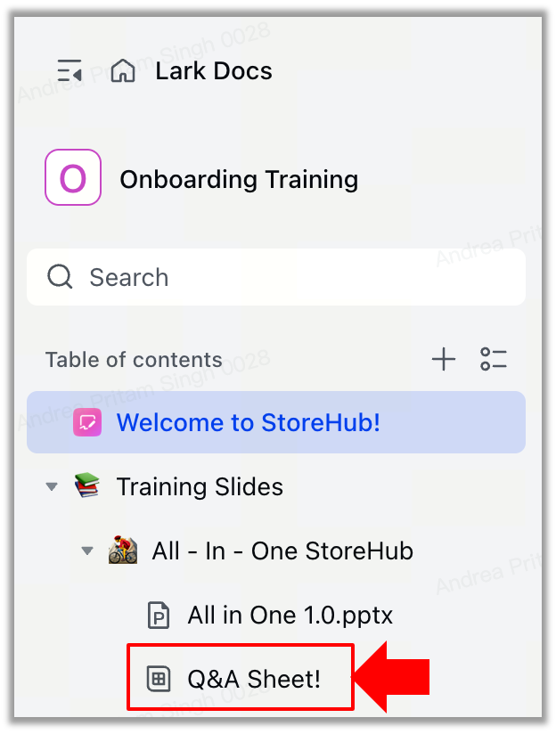


Click Everything!
Throughout your training materials, there are hyperlinks hidden like Easter eggs. Instead of chocolate, they're packed with valuable insights. Don't miss out!
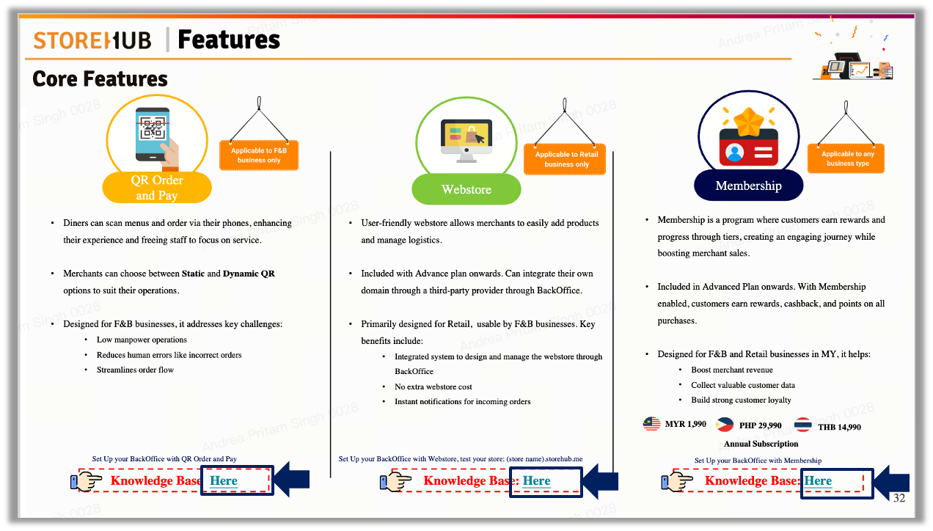

📊 Understanding Your Training Performance Score


Your performance during training is measured through 2 components:

- Learning Score (80% of Final Score)
Your formal assessments contribute to this score:
- All-in-One Quiz (Day 2) - Weighted based on your role
- Role-Specific Assessments (Day 3+) - Details in your role overview

- Participation Score (5% - 20% of Final Score)
Evaluated daily by your trainer across three categories:
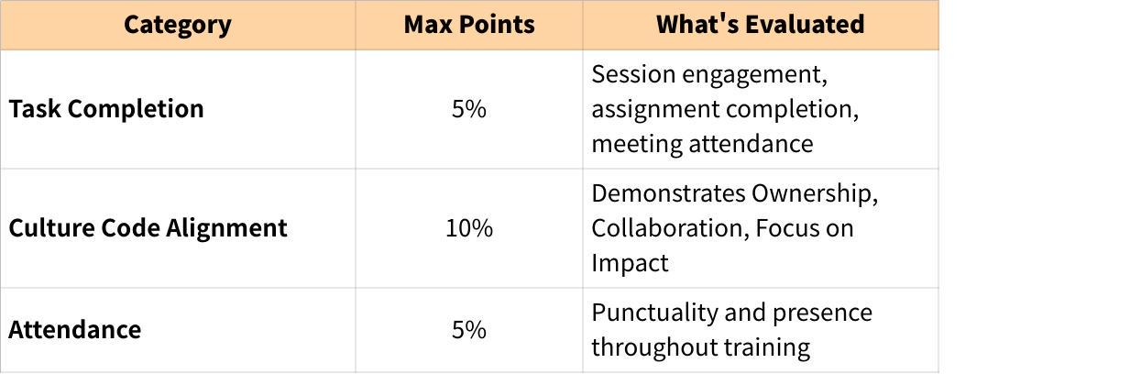
Click the image to view the sheet.

Participation Levels:
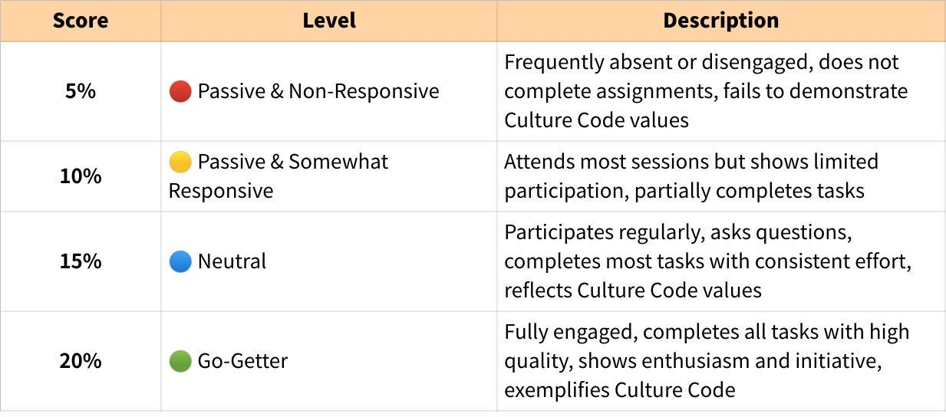
Click the image to view the sheet.
Your Final Training Performance Score = Learning Score (80%) + Participation Score (5-20%)
💡 Pro Tip: High participation can boost your overall score and provide insurance against weaker assessments!

✅ Pre-Training Checklist
Before you jump in, make sure you've got everything you need:

1. Your MacBook 💻
Your trusty sidekick! Ensure your Apple ID is set up using your StoreHub email.
- No Apple ID = No access! 🍏
- Running into issues? As a temporary fix, you can use your personal Apple ID.

2. An iPad 📱
Essential for exploring and getting hands-on with our POS App.
- Don't have one? Ask your coach if they can lend you one.

3. Access to All Tools 🔧
These are the backbone of your training:
- Lark (communication & wiki)
- Google Workspace (email, sheets, docs)
- BackOffice access (role-dependent)
- Other tools (role-specific)

Didn't get the tool access emails? Reach out to your coach ASAP to get sorted.
🔑 Pro Tip: Double-check everything the day before training—because showing up prepared is half the battle! 🚀

📅 Your Day 1-2 Training Schedule

Your journey begins with general training to cover the fundamentals of StoreHub. By Day 2, you'll test your knowledge with a comprehensive quiz- let's see how much sticks!

Day 1: Product Foundation (Self-Study)
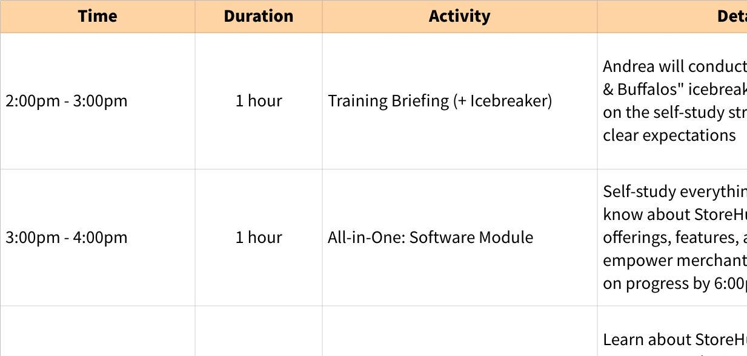
Click the image to view the sheet.
📌 Day 1 Focus: Building product knowledge foundation. Take your time to absorb this knowledge powers everything you'll do at StoreHub.

Day 2: Advanced Navigation & Assessment
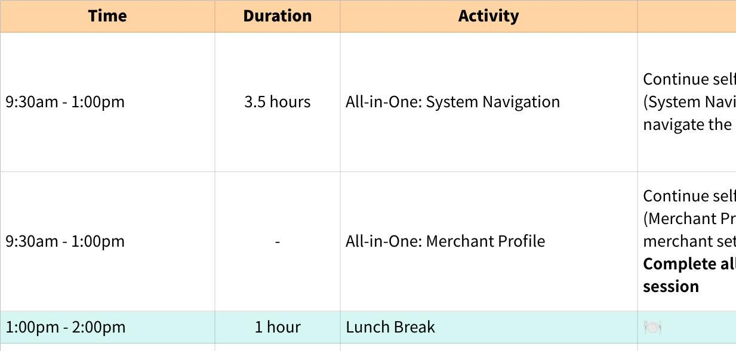
Click the image to view the sheet.
📌 Day 2 Focus: Mastering navigation and proving your foundation knowledge. The All-in-One Quiz is your first formal assessment—open-book, but no retakes!

🎓 The All-in-One Quiz: What You Need to Know

Format:
- 48 questions covering all modules from Day 1-2
- Open-book: You can reference your training slides
- Passing score: 80%
- No retakes: This is your one shot, so prepare well!

Weight:
The All-in-One Quiz weight varies by role:
- Merchant Care: 20%
- Merchant Onboarding Manager: 20%
- Customer Success Manager: 20%
- Onboarding Specialist: 20%
- Onboarding Coordinator: 50% (highest weight!)
- Business Consultant: 20%
- Sales Coordinator: 15%

Strategy Tips:
- Take detailed notes during self-study- you'll reference them in the quiz
- Use the search function (Ctrl+F / Cmd+F) in your slides during the quiz
- Don't rush- you have 1.5 hours, use it wisely
- Read questions carefully- some are scenario-based
- Trust your notes- if you took good notes, you'll do great!

What Happens If You Don't Pass?
Since there are no retakes, failing the All-in-One Quiz significantly impacts your final training score. This policy exists to:
- Build accountability and ownership
- Encourage thorough preparation
- Mirror real-world stakes (you get one chance with merchants!)

But don't stress! The quiz is open-book, and if you've engaged with the material, 80% is very achievable.

👥 Meet the StoreHub Team

Leadership Team
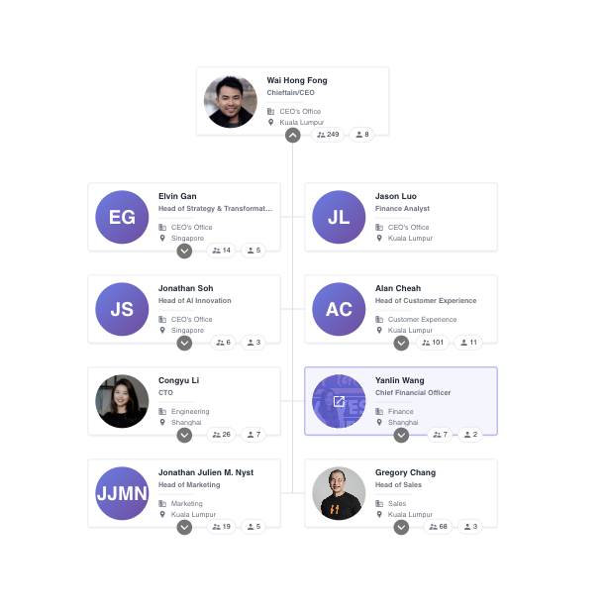

Discover StoreHub Roles 🏢

At StoreHub, every role comes with unique responsibilities, working together to create a seamless experience. Explore the cards below to dive into the details of each role and see how they connect with different departments.

The Sales Clan
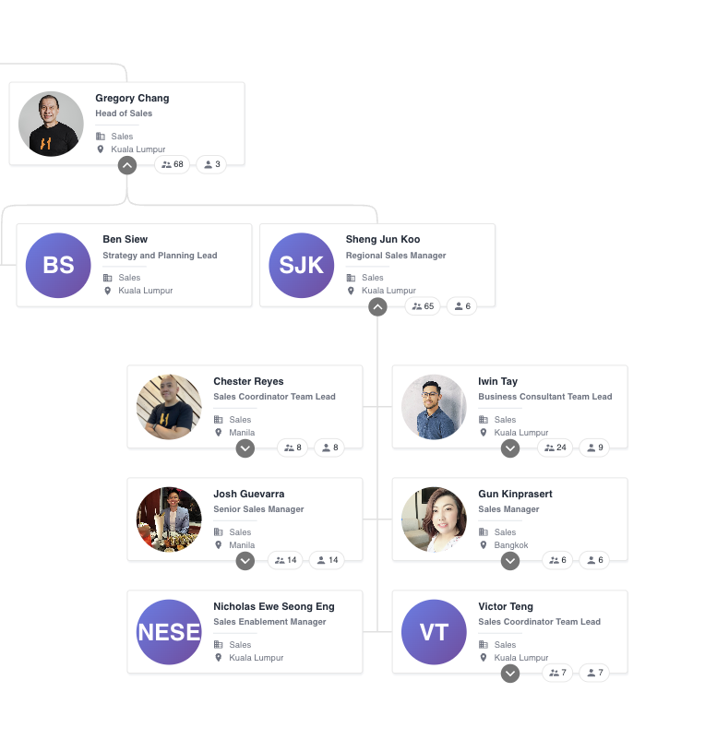

Mission: Merchants' very first point of contact when they express interest in StoreHub. They're the gatekeepers of opportunity, paving the way for a smooth onboarding journey.

Roles:
- Sales Coordinator (SC): Manage inbound leads (farming) and outbound cold calling (hunting). Qualify leads and schedule meetings for Business Consultants.
- Business Consultant (BC): Acquire new merchants, present StoreHub's value, recommend solutions, facilitate handover to Success Team, and collect payments.

Handoff: Once merchants sign up, Sales hands over to the Success Clan.

The Success Clan
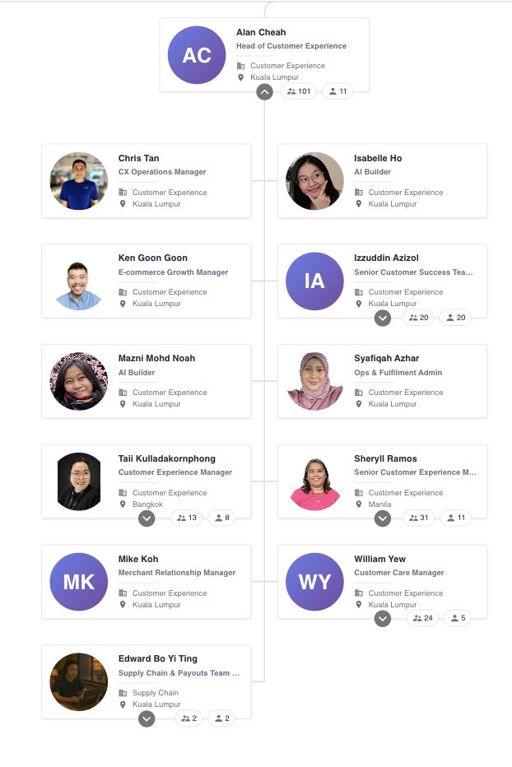

Mission: Ensure merchants are fully prepped and ready to Go Live. Think of them as the ultimate pit crew before the big race!

Pre-Go Live Roles:
- Merchant Onboarding Manager (MOM): Conduct welcome calls, gather merchant info (menu, hardware delivery dates), schedule training, perform Go-Live check-ins, monitor TalkHub messages, and provide 60-day post-launch support.
- Onboarding Specialist (OS): Conduct virtual and onsite training, send training materials, ensure BackOffice setup, prepare customers for Day 1, project-manage VIP installations, and oversee hardware installation.
- Onboarding Coordinator (OC): Configure BackOffice and Beep store, manage collateral requests, ensure 3-day SLA fulfillment, and coordinate delivery with third-party vendors.

Post-Go Live Roles:
- Customer Success Manager (CSM): Manage merchant renewals and expansion, conduct CX surveys, and share insights with Sales/Product/CX teams for continuous improvement.
- Billing Executive (BE): Ensure accurate and timely billing, monitor account balances, resolve discrepancies, manage opportunities, prepare quotations, and forecast financials.

The Care Clan 🛠️
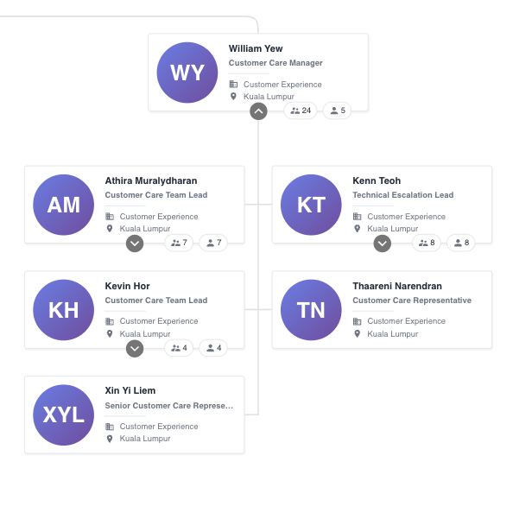
Mission: Provide world-class support to keep merchants running smoothly.
Roles:
- Merchant Care Representative (T1): Provide basic feature recommendations, manage ticket distribution, handle Beep delivery issues (merchant side), guide hardware delivery/installation, perform basic troubleshooting, and resolve account-related issues.
- Merchant Care (T2): Investigate escalated tickets, conduct advanced troubleshooting for hardware/software, provide solutions for complex issues, perform onsite investigations, and test new hardware.
- Beep Care Representative: Manage live Beep Orders (status inquiries, rider updates, payment issues), prepare for Beep Delivery (complaints, payment failures, undelivered orders), resolve disputes, handle vouchers, and coordinate with 3PL riders.
- Fleet Coordinator: Manage StoreHub's Beep fleet (coordination, recruitment, scheduling, payments), oversee 3PL riders (PandaGo, Lalamove), ensure rider availability, and maintain coverage for high-potential merchants.

How Roles Connect: The Merchant Journey
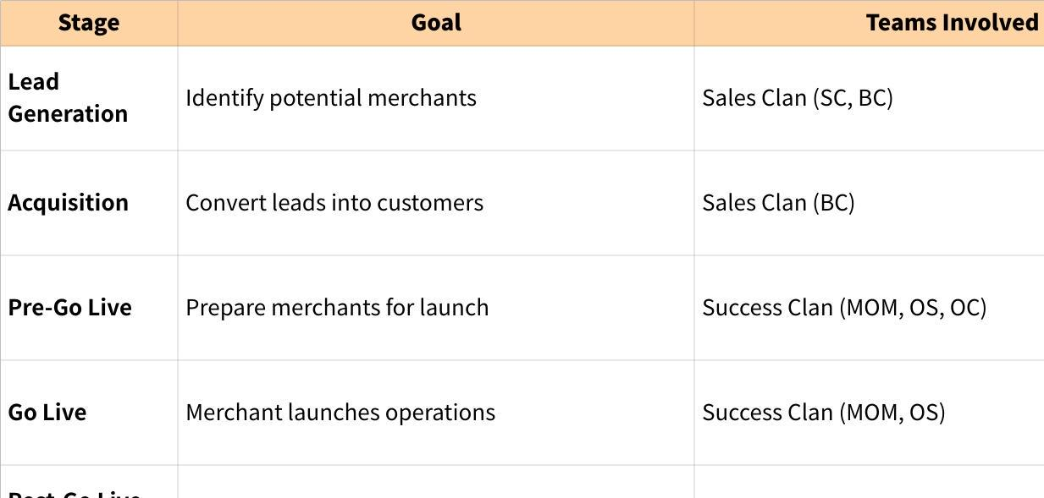
Click the image to view the sheet.
Each stage builds on the last, ensuring merchants are guided, supported, and set up for success as they grow with StoreHub.

🎯 What Happens After Day 2?

Congratulations! By the end of Day 2, you'll have:
- ✅ Mastered StoreHub's product foundation
- ✅ Passed the All-in-One Quiz (80%+)
- ✅ Understood how your role fits into the bigger picture

Next Step: Role-Specific Training (Day 3+)

On the evening of Day 2 (around 8pm), you'll receive a comprehensive role-specific training overview via email. This document will cover:
- Your role's mission and core responsibilities
- Day-by-day schedule with exact timings (Day 3 onwards)
- Assessment breakdown and weightage specific to your role
- Your assigned coach and support contacts
- Pro tips for success in your role

💡 Pro Tip: Review your role-specific overview that evening so you arrive Day 3 ready to hit the ground running!

📚 Resources & Support

Where to Find Materials
- Training Wiki: All slides and resources live in the Lark Wiki (link provided in welcome email)
- Questions Sheet: Use the provided sheet to track questions for trainer sync-ups
- Training Schedule: Refer back to this overview for Day 1-2 timeline

Who to Contact
For Logistical Support:
- Your Trainer (Andrea): andrea.kaur@storehub.com
- Scheduling questions
- Access to materials
- General training logistics

For Role-Specific Guidance:
- Your Coach/Manager: (Assigned based on your region and role- details in your role-specific overview)
- Technical content clarification
- Assessment feedback
- Day 3+ training coordination

For Technical Issues:
- IT/HR: Contact for MacBook, iPad, or tool access issues

🚀 Ready to Begin?
You've got everything you need to succeed. Remember:
- You're in control of your learning pace
- We've got your back with daily check-ins and support
- Time management is key to staying on track
- Ask questions freely—no question is too small
- Participation matters—engagement boosts your score

Your Checklist:
- Review this overview thoroughly
- Confirm MacBook and iPad setup
- Verify access to all tools (Lark, Google Workspace, etc.)
- Bookmark the Training Wiki
- Set aside focused time for self-study (minimize distractions)
- Prepare to take detailed notes
- Get ready for an awesome learning journey!

Final Thoughts

Training at StoreHub is designed to empower you with knowledge, skills, and confidence. The self-study structure respects your autonomy while providing guardrails and support when needed.

This is your chance to:
- Absorb how StoreHub empowers merchants
- Understand the product deeply
- Build relationships with your trainer and peers
- Prove your accountability and proactivity
- Set the foundation for a successful career at StoreHub

Now go forth and make Day 1-2 incredible! 💪
Welcome to the team—we're excited to have you here!

